# write a python program to simulate smoothening and sharpening operation on image using spatial filter import cv2 import numpy as np # Load the image image = cv2.imread(“image_smooth.jpg")

# Define the Gaussian kernel for smoothing

# Smoothing smoothed_image = cv2.GaussianBlur(image, (7, 7), 2)

# Define a sharpening kernel

# Sharpening sharpened_image = cv2.addWeighted(image, 1.7, smoothed_image, -0.7, 0)

# Display the original image, smoothed, and sharpened images cv2.imshow('Original Image', image) cv2.imshow('Smoothed Image', smoothed_image) cv2.imshow('Sharpened Image', sharpened_image) cv2.waitKey(0) cv2.destroyAllWindows()

Output:
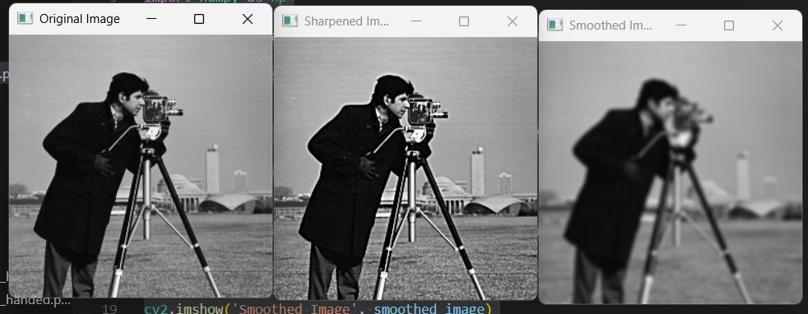

write a python program to simulate smoothening using Averaging linear filters import cv2 import numpy as np # Load the image image = cv2.imread(" image_smooth.jpg")

# Define the size of the Averaging filter kernel

# Apply Gaussian Blur for better smoothing and clarity smoothed_image = cv2.GaussianBlur(image, (7, 7), 1.5)

# Display the original and smoothed images cv2.imshow('Original Image', image) cv2.imshow('Smoothed Image', smoothed_image) cv2.waitKey(0) cv2.destroyAllWindows()
output:
